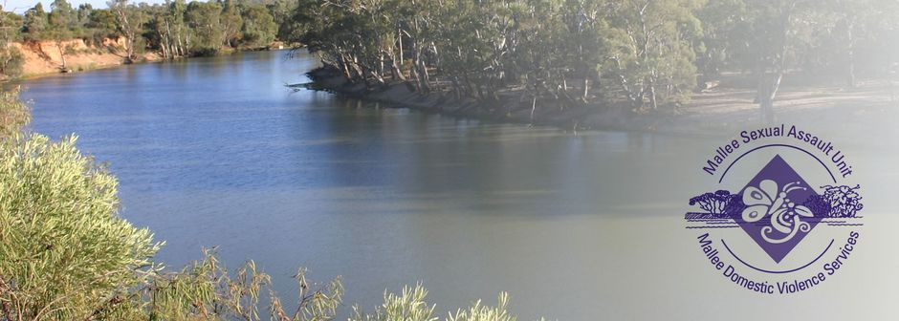
Case Manager Refuge
- Purposeful work.
- Great Salary Packaging benefits offered.
- Professional development and training opportunities available.
- Equal Opportunity and Rainbow Tick Accredited employer.

The Mallee Sexual Assault Unit (MSAU) and Mallee Domestic Violence Services (MDVS) provides services for women, men and children throughout the Northern and Southern Mallee region, border communities of New South Wales, the Mallee Track and Shires of Gannawarra and Buloke. Our services are free and available to all victim survivors.

The Role
We have an exciting opportunity in our Crisis Response Team for another Case Manager at our purpose-built crisis refuge facility that provides 24/7 support and independent accommodation for family violence victim survivors and their children in Mildura, Victoria.
In this role you will support victim survivors accommodated at the Refuge or other crisis accommodation settings. You will be work within a case management framework whilst providing crisis response which includes the provision of information, advocacy, referral and support to clients escaping family violence.
These positions work within a 24-hour roster including weekday/weekend and overnight shifts.

Key responsibilities for these roles include:
- Provide direct case management, support, and advocacy for victim survivors of family violence accommodated by the service.
- Provide crisis intake, counselling, support, information, advocacy, and assistance to all clients of the service in crisis situations and/or requiring follow-up support/referral.
- Work as part of a team ensuring the provision of a safe and supportive environment in which victim survivors make their own decisions and choices.
- Develop, plan and supervise the implementation of educational and/or developmental programs for clients.
- Facilitate access to other services and resources and advocate on behalf of service users when requested.
- Maintain all necessary administrative processes and systems for the efficient operation of the service, including financial, statistical and client files and databases.
What you will need to succeed
The successful candidate will have:
- Tertiary qualifications in Social Work or the equivalent.
- Crisis intervention and counselling skills.
- Experience using risk assessment and risk management frameworks.
- Knowledge and understanding of the impact of family violence and sexual assault on victim survivors and their families.
- Knowledge of housing/homelessness issues
- Understanding of current legislation and standards
- Ability to promote the cultural safety of children from Aboriginal and CALD backgrounds and any child with a disability.
- Excellent written and verbal communication skills

All applicants must have the right to work in Australia, be willing and able to obtain a Working with Children’s Check for both VIC & NSW, a National Police Check and hold a current Driver’s Licence.
For enquiries, please contact Deanne Kontrec, Human Resources Manager MSAU-MDVS on (03) 5025 5400 or via email careers@msau-mdvs.org.au.

To obtain a detailed Position Description please visit our website https://msau-mdvs.org.au/employment.
Applications close at 12 midnight Sunday, 5th May 2024.

