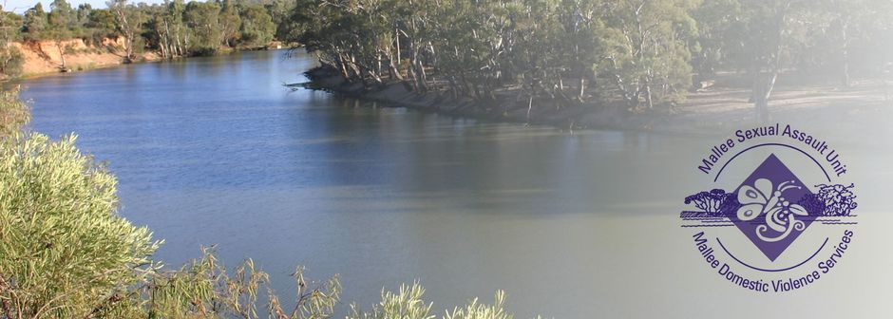
Hub Practitioner – The Orange Door
- Purposeful work.
- Great Salary Packaging benefits offered.
- Professional development, and training opportunities available.
- Diverse, innovative team.
- Equal Opportunity and Rainbow Tick Accredited employer.

The Mallee Sexual Assault Unit (MSAU) and Mallee Domestic Violence Services (MDVS) provides services for women, men and children throughout the Northern and Southern Mallee region, border communities of New South Wales, the Mallee Track and Shires of Gannawarra and Buloke. Our services are free and available to all victim survivors.

The Role
The Hub Practitioner will work within the multi-disciplinary team to deliver high quality, safe and effective responses to women, children and young people experiencing family violence, along with families who need assistance with the care and wellbeing of children, who are seeking support and services through The Orange Door.
You will conduct risk and needs assessments utilising established frameworks that will require a high level of professional discernment and work collaboratively with our partner organisations to provide an integrated response to those seeking support.
Key responsibilities for these roles include:
- Conduct appropriate risk assessments and safety planning
- Present clients with the options for referrals to resource them in making informed decisions for their personal situation.
- Facilitating and completing referrals.
- Providing short term supportive counselling.
- Providing a point of contact for secondary consultation, advice and information.

What you will need to succeed
The successful candidate will have:
- A Bachelor of Social Work, or the equivalent.
- Ability to engage strong risk assessment and risk management skills using the required framework and information sharing schemes.
- Knowledge and skills in case management principles and practice.
- Have a client focused approach that facilitates empowerment and independence for victim survivors and the safety and security for service users and their children.
- Understanding of, and a commitment to maintaining professional practice and boundaries.
- Experience in making sound decisions in sometimes crisis situations.
- Knowledge and experience working in a clinical setting, along with the capability to embed integrated practice and quality clinical practice.
- Ability to work cooperatively and collaboratively with service users, colleagues and other service providers.
- An understanding of the nature, scope and impact of family violence on victim survivors.

Knowledge and an understanding of the Mallee Health & Community Service sectors along with relevant legislation be an advantage but not essential.

All applicants must have the right to work in Australia, be willing and able to obtain a Working with Children’s Check for both VIC & NSW, a National Police Check and hold a current Driver’s Licence.

For enquiries, please contact Deanne Kontrec, Human Resources Manager MSAU-MDVS on (03) 5025 5400 or via email careers@msau-mdvs.org.au.

To obtain a detailed Position Description please visit our website https://msau-mdvs.org.au/employment.

Applications close at midnight Sunday, 19th May 2024.

