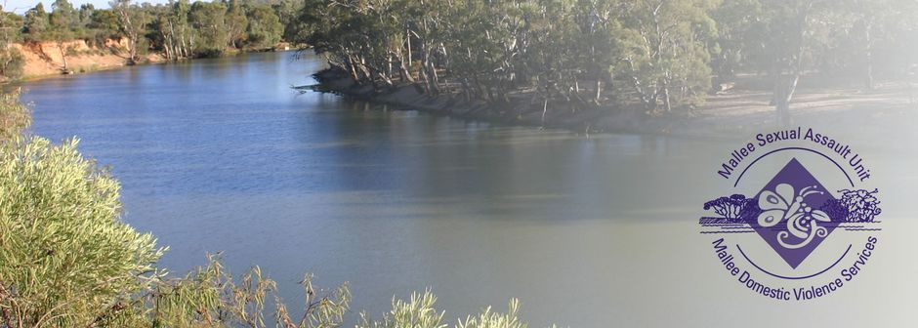

**Case Manager – Family Violence (Swan Hill)**

* Great Salary Packaging benefits offered.
* Professional development and training opportunities available.
* Equal Opportunity and Rainbow Tick Accredited employer.

The Mallee Sexual Assault Unit (MSAU) and Mallee Domestic Violence Services (MDVS) provides services for women, men and children throughout the Northern and Southern Mallee region, border communities of New South Wales, the Mallee Track and Shires of Gannawarra and Buloke. Our services are free and available to all victim survivors.

**The Role**

We have an exciting opportunity for a Case Manager – Family Violence to join our team in Swan Hill, Victoria.

In this role you will provide effective, safe and professional services and support to those who have experienced family and sexual violence.

**Key responsibilities for these roles include:**

* Delivering high quality, inclusive and flexible case management services including client engagement, intake and assessment, case planning, intervention, review, and case closure to victim survivors of family violence.
* Undertake and coordinate effective high quality case management for family violence victim survivors in accordance with MARAM and relevant practice guidelines.
* Engage with victim survivors, their families and health/community services to deliver integrated ‘evidence based’ victim-directed and meaningful service to all people.
* Participate and deliver effective work processes to ensure the delivery of program throughput, outputs and KPI’s.
* Utilise principals of recovery orientated practice, support and assist clients to develop skills.
* Encourage positive relationships and support networks.
* Educate, encourage, and support victim survivors to engage with internal and external support services.
* Support victim survivors to identify short and long term goals through effective case planning.
* Provide guidance and encouragement to victim survivors to achieve agreed goals as detailed in their action plan.
* Establish and maintain collaborative and supportive relationships with clients, service providers, other team members and the local community through demonstrating respect, compassion, and the willingness to understand differences in culture and customs.

**What you will need to succeed**

The successful candidate will have:

* Hold a Bachelor of Social Work or other equivalent qualification.
* Demonstrated experience delivering goal-orientated case management.
* Demonstrated experience providing holistic evidence-based interventions and referrals.
* High level interpersonal skills, and the ability to connect with and build trusting therapeutic relationships with people.
* Excellent written and verbal communication skills
* The ability to work as part of a team, and autonomously.
* Experience with working in collaboration with other services to ensure integrated care.

All applicants must have the right to work in Australia, be willing and able to obtain a Working with Children’s Check for both VIC & NSW, a National Police Check and hold a current Driver’s Licence.

For enquiries, please contact Deanne Kontrec, Human Resources Manager MSAU-MDVS on (03) 5025 5400 or via email [careers@msau-mdvs.org.au](mailto:careers@msau-mdvs.org.au).

To obtain a detailed Position Description or information on how to apply, please visit our website <https://msau-mdvs.org.au/employment>.

**Applications close at 12 midnight Sunday, 26th May 2024.**