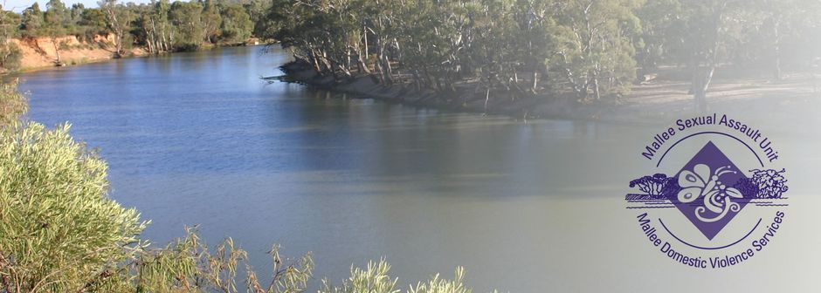
Counsellor/Advocate – Sexual Assault
- Purposeful work.
- Great Salary Packaging benefits offered.
- Professional development and training opportunities available.
- Equal Opportunity and Rainbow Tick Accredited employer.

The Mallee Sexual Assault Unit (MSAU) and Mallee Domestic Violence Services (MDVS) provides services for women, men and children throughout the Northern and Southern Mallee region, border communities of New South Wales, the Mallee Track and Shires of Gannawarra and Buloke. Our services are free and available to all victim survivors.

The Role
We have an exciting opportunity in our Sexual Assault and Therapeutic Services Team for a Counsellor/Advocate - Sexual Assault located in Mildura, Victoria.
In this role you will therapeutically support adults, young people and children who have experienced sexual assault, as well as their non-offending family members.

Key responsibilities for these roles include:
- Deliver high quality, inclusive and flexible counselling, advocacy and/or therapeutic support including client engagement, intake and assessment, case planning, intervention, review and case closure to victim survivors of sexual assault.
- Engage with victim survivors and their families to deliver ‘evidence based’ person directed support.
- Support victim survivors to identify and implement short and long term goals through effective case planning.
- Uphold the values of respect, integrity, collaboration, care, accountability and innovation.
- Follow current standards of practice and legislation relevant to the role.
- From time to time you will be responsible for recall and perform the intake function.

What you will need to succeed
The successful candidate will have:
- Tertiary qualifications in Social Work or the equivalent.
- Demonstrated experience delivering trauma informed case management or counselling to victim survivors.
- High level interpersonal skills and the ability to connect with and build trusting therapeutic relationships with people.
- Excellent written and verbal communication skills
- The ability to work as part of a team, and autonomously.
- Experience with working in collaboration with other services to ensure integrated care for the victim survivor.

All applicants must have the right to work in Australia, be willing and able to obtain a Working with Children’s Check for both VIC & NSW, a National Police Check and hold a current Driver’s Licence.
For enquiries, please contact Deanne Kontrec, Human Resources Manager MSAU-MDVS on (03) 5025 5400 or via email careers@msau-mdvs.org.au.

To obtain a detailed Position Description or information on how to apply, please visit our website https://msau-mdvs.org.au/employment.
Applications close at 12 midnight Sunday, 14th April 2024.

