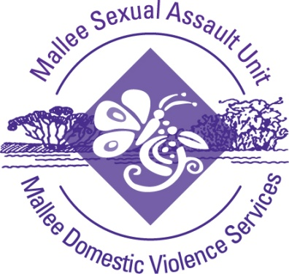
CONTINUOUS QUALITY IMPROVEMENT SURVEY
MALLEE SEXUAL ASSAULT UNIT INC. MALLEE DOMESTIC VIOLENCE SERVICES

Mallee Sexual Assault Unit Inc. Mallee Domestic Violence Services is a service providing counselling, support services and advocacy for victims / survivors of sexual assault and family violence.

Mallee Sexual Assault Unit Inc. Mallee Domestic Violence Services is reviewing its services and operations to improve the quality of services provided to the Mallee region. As part of our quality improvement process, we are seeking feedback from your organisation on the way we:

Mallee Sexual Assault Unit Inc. Mallee Domestic Violence Services is committed to the principles of social justice and aims to ensure that every individual is treated with dignity and respect regardless of their ability, cultural background, ethnicity, gender identity, sexual orientation or religion / faith.

- Make and receive referrals
- Communicate with you
- Case manage clients
- Deliver business and partnerships

- What is the name of your organisation?

- Which of the following activities best describes our business partnership with your organisation? (please tick the appropriate descriptors)

We have a Memorandum of Understanding or formal Service Protocol

We receive client referrals from your organisation

We make client referrals to your organisation

We share joint case management of client with your organisation

We regularly network through meetings and working committees

Any other type of relationship, please detail.

- How frequently do you have contact with our service?
Regularly □ Occasionally □ Infrequently □
- Please indicate your level of satisfaction in each of the following areas.

Please rate each of the following :  1 : Does not apply  2 : Very dissatisfied  3 : Dissatisfied  4 : Satisfied  5 : Very satisfied | 1 | 2 | 3 | 4 | 5
- Are you satisfied with the information provided to the community about our service?

- How satisfied with the appropriateness of information we provide to your organisation when we make a client referral?

- How satisfied are you with the timelines for our response to your client referrals?

- How satisfied are you with the crisis response we provide through intake and refuge programs?

- How satisfied are you with the level of safety we provide for our clients?

- How satisfied are you with the level for support we provide for our clients?

- How satisfied are you with the standard of our facilities?

- How satisfied are you with the level of skill demonstrated by our staff?

- How satisfied are you that we provide diverse and intersectionality appropriate services?

- How satisfied are you that we respect the rights of our clients?

- How satisfied are you with our response to grievances?

- How satisfied are you with community and client engagement?

- How satisfied are you with our level of collaboration with your agency?

- How satisfied are you with our level of assistance?

- How satisfied are you with our level of community participation?
Please rate each of the following :  1 : Does not apply  2 : Very dissatisfied  3 : Dissatisfied  4 : Satisfied  5 : Very satisfied | 1 | 2 | 3 | 4 | 5
- How satisfied are you with the way in which our service responds to clients who are jointly case managed?

- How satisfied are you with the punctuality and reliability of our staff?

- What do you think we do well as a service?

- How could we improve our practice?

- Do you have any further feedback?

- Would you like to be contacted regarding any comments that you have made in this survey?

MALLEE SEXUAL ASSAULT UNIT INC. MALLE DOMESTIC VIOLENCE SERVICES
THANK YOU FOR YOUR TIME AND FEEDBACK.

Version | Date | Author / Approver | Reason / Changes
Version 1 |  |  | Approved
Version 1.1 |  |  | Minor amendment
Version 1.2 |  |  | Minor amendment
Version 1.3 | 9/05/2019 | Wendy Morello | Minor amendment
Version 1.4 | 7/10/2019 | Wendy Morello | Minor amendment

